Comparative analysis of global SME boards, taking the Nigerian Growth Board as the lens

by

Chengcheng Peng

An honors thesis submitted in partial fulfillment

of the requirements for the degree of

Bachelor of Science

Business and Economics Honors Program

NYU Shanghai

May 2023

Professor Marti G. Subrahmanyam Professor Guodong Chen

Professor Christina Wang

Professor Ye Jin

Faculty Advisors Thesis Advisor

**Abstract**

Small and medium-sized enterprises (SMEs) in developing countries are facing a huge financial gap, especially in Nigeria, where SMEs contribute 84% of employment but have a funding gap of N 1 trillion. SME exchange boards are an important means for these SMEs to obtain funds through equity financing. This paper hopes to identify the most important factors (liquidity, market capitalization, etc.) that promote the contribution of SME boards to the development of SMEs with Nigeria as the main object of analysis. After that, various machine-learning methods including multiple regression, LASSO, and RF will be used to determine the importance of the different factors and PCA will be used to corroborate. Finally, the Random Forest approach is proved to be the most appropriate model, and sensitivity analysis for “Listing Fee” and “DA” will be completed to find the appropriate range of parameter values.

**Acknowledgment**

I would like to thank the thesis advisor, Professor Guodong Chen, for supporting my research field and providing guidance for specific machine learning methods. The communication with Professor Chen greatly improved my research knowledge, data analysis skills, and vision.

I would like to express my gratitude to Prof. Christina Wang, Professor Marti G. Subrahmanyam, and Professor Ye Jin for helping determine research topics, conducting personal meetings, coordinating weekly lectures, and providing a wealth of research resources.

Last but not least, I would like to show my gratitude to the speakers in every Friday’s Honor Programs lecture. These valuable courses allowed my fellow students and me to acquire a comprehensive insight into useful skills like materials collection, writing, and presentation, and various knowledge of finance, economics, and marketing.

**Introduction**

Small and medium-sized enterprises (SMEs) financing is currently a concern worldwide, especially in emerging markets. For example, it is estimated that SMEs in Africa provide approximately 80% of employment. Because of their low credit and small size, banks often have various constraints for SMEs’ finance. That’s why the equity markets become an increasingly important financing way, that many governments pay attention to. There are more than 20 stock boards focusing on SMEs around the world, such as the Beijing Stock Exchange in China and South African Altx, established by the most mature JSE in Africa. These boards are set to support SMEs’ development through relatively relaxed listing requirements and to provide easier opportunities. Different countries’ boards are in significantly various developing stages, and we will use Africa’s largest economy Nigeria, with its SME board “Growth Board”, as a lens to see the importance and problems of existing SME boards.

SMEs in Nigeria contributed 49% of the GDP and 84% of employment (PwC, 7). Although playing a huge role in employment, economy, and social stability, Nigerian SMEs are experiencing a huge financing gap, reaching N 617.3 billion annually before COVID-19. And according to the managing director of the Bank of Industry Olukayode Pitan’s estimation, this gap is even about N 1 trillion now.

As more SMEs face problems to get funding from banks, policymakers are now increasingly recognizing that public equity is a significant financing alternative for SMEs, and that’s why the Growth Board was set, which provides listing opportunities for companies with a market capitalization of less than NGN 500M.

The Growth Board sets no profitability requirements, assigns professional advisors for every owner, and only requires a low free float rate, thus providing SMEs with a friendlier platform for raising capital. In addition, according to the official handbook of the Growth Board, many SMEs in Nigeria have received VC investment, and even C-series fundings account for 64% of their total funding sources (4). This should have provided a good funding basis for SMEs to go public. However, despite these benefits, the Growth Board has only six listed companies currently. This clearly shows that the Nigerian SME Board is still not functioning as expected, and SME owners are worried about going public.

The main reason for this situation is that foreign investors account for the majority of Nigeria's VC, but the local stock market has many restrictions on foreign investors (Egwuatu). Besides, even domestic institutional investors are increasingly choosing European and North American stock markets because of the poor liquidity of the Growth Board. The lack of investors creates low liquidity, which in turn reduces the confidence of SMEs to go public, forming a vicious circle. This is precisely the reason why last SME Board, ASEM, which is the board before the Growth Board, was canceled: low liquidity and a lack of interest from SMEs. Similar problems also happen in Kenya and Botswana, where less than 5 companies are tradable on their SME boards. Therefore, the questions of how to find the factors that contribute to the success of an SME board, and how to promote the learning experience of different countries’ SME boards, become the focus of the issue. To find out these significant questions, this comparative analysis of the 19 SME boards around the world is conducted, using machine learning methods of PCA, LASSO regression, and Random Forest.

**Institutional background**

Stock exchanges are not the only financing way for SMEs, but more and more countries find that other alternatives are becoming less helpful. For example, there are already various institutions in place to support SMEs in Nigeria, like the National Microfinance Bank. However, banks may not be the best solution to the current problem, as can be seen from the fact that lending to SMEs was only 5% of total commercial bank lending (African Business). What’s more, due to their financing constraints toward SMEs and the poor implementations of existing support programs, banks, the SMEs’ “most important” financing channel, have even been proven by several papers to have no positive impact on SME development (Obieche and Ihejirika, 40; Ibrahim, 29). This doesn’t only happen in Nigeria. According to Schellhase and Woodsome, more banks have curbed their lending to SMEs in the wake of the global financial crisis (1). And IFC estimates that in developing countries, SMEs’ credit gap has exceeded 25% of their total credit.

Stock exchange especially for SMEs needs to play a more important role in the current situation, but many existing barriers are limiting SMEs from going public. For example, even in Kenya, which is famous for its high-growth tech start-ups in Africa, only 13% of SMEs have an annual growth rate larger than 10%, which cannot fully satisfy investors’ return expectations. Exploring key factors for SME Board’s success, helping more SMEs go public and investors get a decent return, may be helpful to the existing problems.

**Literature review & Variable explanation**

Eight potential factors are discussed here to be the independent variables, and a measure of SME performance is the dependent variable. The reasons why each factor is seen as necessary, as well as the related sources, are described in this section.

1. **Liquidity (Turnover Ratio)**

According to Maher and Andersson’s paper about the effect on firm performance, which is published on SSRN, “Insider systems, characterized by small and illiquid public capital markets……, can impinge upon the development of a vibrant and thriving SME sector” (20). Similarly, in Schellhase’s paper comparing different SME boards, the turnover ratio, which is the trading value in a specific period, over the average market capitalization during that period, is used to represent the liquidity of the board (10). As the largest problem Growth Board is facing, this factor is necessary.

The Turnover Ratios are shown below, and we can see that different boards have very different ratios. This ratio is highly correlated with the number of listing companies. For example, for those whose ratios are almost zero, they usually don’t have more than 10 companies. But for Thailand MAI whose ratios exceeded 100%, this number is 235.

**Figure 1**: Turnover Ratios (Liquidity) of 13 SME Boards

1. **Number of Listing Companies**

According to Peterhoff, Romeo, and Calvey’s paper in 2014, SME boards must have at least 100 listings within five years after they are established, to become sustainable (6). Of course, not all boards meet this requirement, but some SME boards are subsidized by the main exchange, so these boards do not necessarily have to be self-sufficient. That’s also why that paper is challenged. Therefore, the number of listing companies could be put into the model to test the significance.

1. **Profit Requirement**

Most SME boards don’t have a mandatory requirement for profit. For example, both South African Altx and Nigerian Growth Board do not require any record of pre-tax profits, given the potential profitability difficulties of startup companies and the existence of the "valley of death". But some relatively large SME boards like Thailand’s Alternative and Chinese BSE do have profit requirements. The requirement can be set as a dummy variable in the model, testing whether it has a positive impact on SME boards.

1. **Mandatory Advisor**

According to Ozturk’s paper, which ranks 27 in SSRN, “Investment in human capital can have little impact on growth unless people can use education in competitive and open markets” (3). This reflects the dilemma of developing countries like Nigeria: Although the government provides different platforms of programs for SME owners, lack of knowledge and experience made those owners unable or even have no idea about access to these funds. Basic financial education for SME owners is essential. As a result, 13 of the 19 SME boards in this paper have a requirement for SMEs to appoint a Listing Advisor, who will accompany the company throughout the listing period and provide professional support. They can offer listing education to SME owners but will also be seen as a burden who need high pay, so exploring whether this dummy variable will influence SME performance is valuable.

1. **Time of existence**

19 boards were established between 2006 and 2021. Factors like experience in dealing with listed companies and past cases will affect the company's listing experience on the board and even its future performance. However, since the year (Y) itself is an ordered categorical data, we convert it to 2023-Y, which is the number of years that have passed since its establishment.

1. **Market Capitalization**

Among the SME boards, there is a huge difference in size, from $7 million in Tunisia to $14,818 million in Thailand. The total size itself will cause different characteristics of various markets, and also has a strong correlation with factors like liquidity. Therefore, this factor may be merged with others when we use PCA to do the dimension reduction.

1. **Listing Fee**

Both Kenya’s Growth Enterprise Market Segment and China’s BSE have announced to waive the initial application fee of the SME boards. For vulnerable and underfunded SMEs, an appropriate listing fee is an important factor. What’s more, the listing fee is the advantage of Growth Board over other boards. Among all 15 sets of available data, Growth Board’s $570 listing fee is the second lowest. There may still be spaces for Growth Board to improve itself, such as the categorical charging methods mentioned by Egwuatu, which is believed to be able to attract more SMEs for NSE.

1. **Capitalization of Main Board**

SME Boards are usually set up and funded by Main Boards, and companies listed on them can also graduate to main boards if they meet certain requirements. Some countries (such as Malawi and Zambia) even display all companies on two boards Indiscriminately on their official websites. In one word, the size of the main board affects the size of the affiliated Board, which is why the Market Capitalization of Main Boards is also added to independent variables.

**Dependent Variable**

For the dependent variable, Ovat uses SME’s performance over GDP in the paper “*Commercial Banks' Credit and the Growth of Small and Medium Scale Enterprises: the Nigerian Experience*” to get an indicator to measure the SME’s contribution to the country (26). Similarly, the ratio of SME value added over GDP is also used as the dependent variable in this paper, showing the SME’s performance. SME stock indexes themselves were also considered before, but this may cause the problem of sample selection **bias**: when we choose the SME board indexes, we automatically ignore those SMEs that don’t go public, which are actually the majority. Besides, I also tried the SME’s financial gap over GDP as the dependent variable, but the R squares for most regressions were not satisfying (lower than 50%). So, the SMEs’ contribution to GDP is finally chosen.

**Data**

The data mainly comes from the **SME board website**. All of the boards offer listing **requirements**, where information about listing fees, time, and advisors can be found. Most of them have the basic statics on the websites like total market capitalization and turnover ratio. The picture below is one example of the statistics on the website of Thailand’s SME board: Market of Alternative Investment.

图形用户界面

**Figure 2**: Turnover Ratio of Thailand’s Alternative Investment Market

For those boards without such statistics, I found the market capitalization of all listing companies (average of the beginning and the end of the year) and added them up. And then, the traded values during the period of one year can be found in the annual report and be used as the nominator. The formula is as below:

$$Turnover Ratio=\frac{Trading value}{ average market capitalization}$$

After getting the original data, the translation was done because some boards only report in the local language. And then all of the currency units were changed into USD for the convenience of comparison. Some facts are shown below

The median of total market capitalization is $436.4 million, and the median of listing company numbers is 32.5. The free float rate, which means the minimization of the percentage of shares that the listing company must sell publicly, is shown below. We can see that 50% of the boards have a free float requirement of 10%, and there are only two boards with more than 25% free flout rates.

**Figure 3**: Free Float Rates for SME Boards

Besides, only three boards have the profitability requirement for SMEs, which fits the mission of SME boards to support start-ups. As for the listing fee, which is a significant concern of SME owners, Kenya has the highest fee, while Tunisia’s fee is the lowest (Application fees for China’s BSE are waived, but companies entering it typically have already been listed once on more junior boards). Kenya announced a reduction of its listing fee in 2017, but the efficiency is not as satisfactory, and its fee is still the highest among the 19 boards.

**Figure 4**: Listing Fee ($) of 11 SME Boards

**Methodology and Results**

In this section, three different models will be used to determine the most important factors for a successful SME board. And then PCA will be used to consolidate the conclusion. All these four methods are also mentioned and supported in Liu et al.’s paper about the usage of machine learning in economic growth (3).

To deal with the problems of small samples, k-fold cross-validation is leveraged when dividing the training group and testing group. In case different methods don’t converge in the conclusion, we use mean absolute error and variance as two metrics to compare different models, and determine the most proper model to use.

**Multiple Regression**

Firstly, 10 boards with all important factors available are chosen. And then the multiple regression for 8 factors is done. The reason I didn’t choose more factors is that the number of factors will exceed the number of samples. So, we just pause and continue with the regression of all samples together.

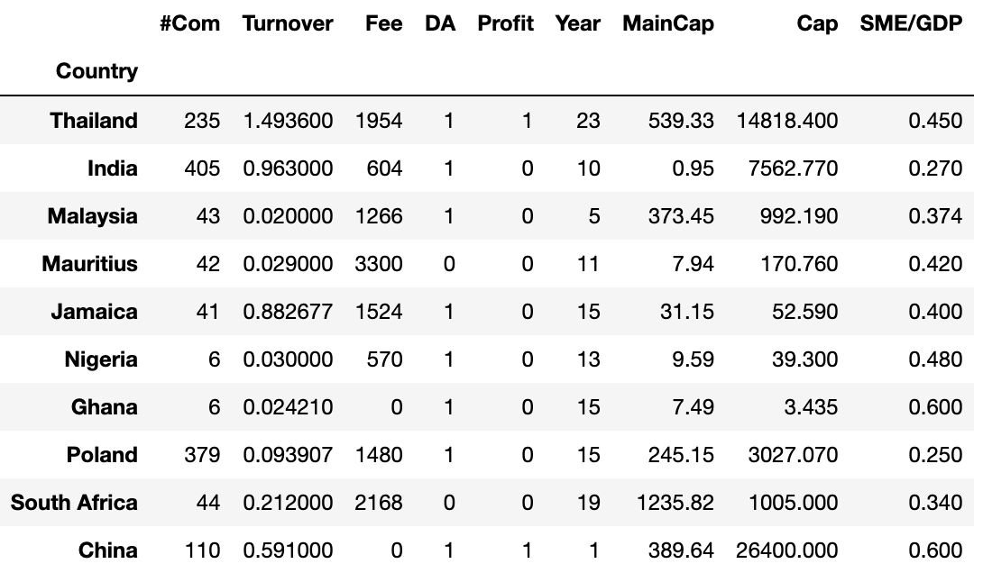

**Table 1**: Data of the Models

The results of multiple regression 1 are as below:

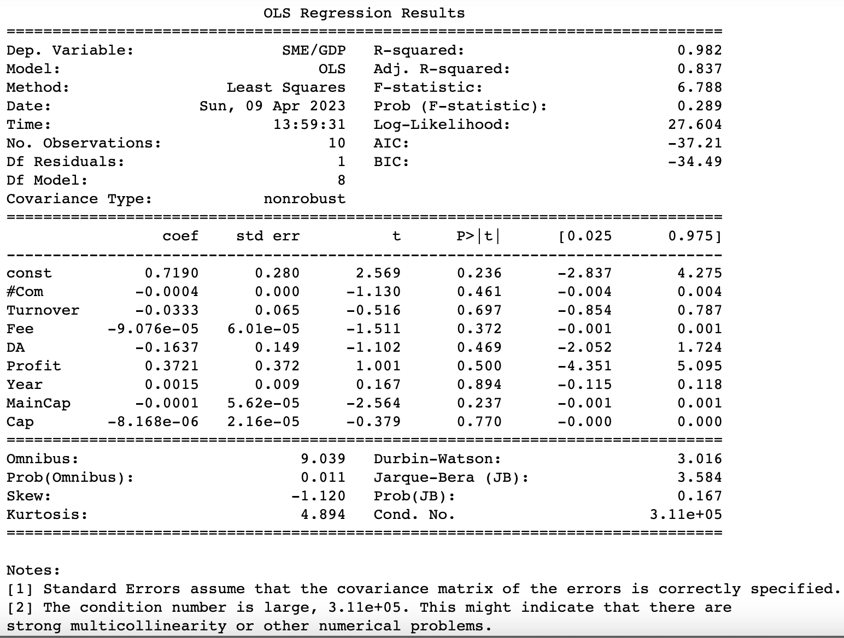

**Figure 5**: Results of the Multiple Regression 1

We find that the coefficients of many factors are so small, and that is because many factors’ units are much larger than the dependent variables. Therefore, the “log” function is used to check the ratio relationship. And also, Turnover ratios and SME/GDP can also be written as the number instead of the percentage (that is writing 0.45 as 45 directly, aiming to close the gap between absolute numbers).

After those modifications, we do the updated multiple regression 2.

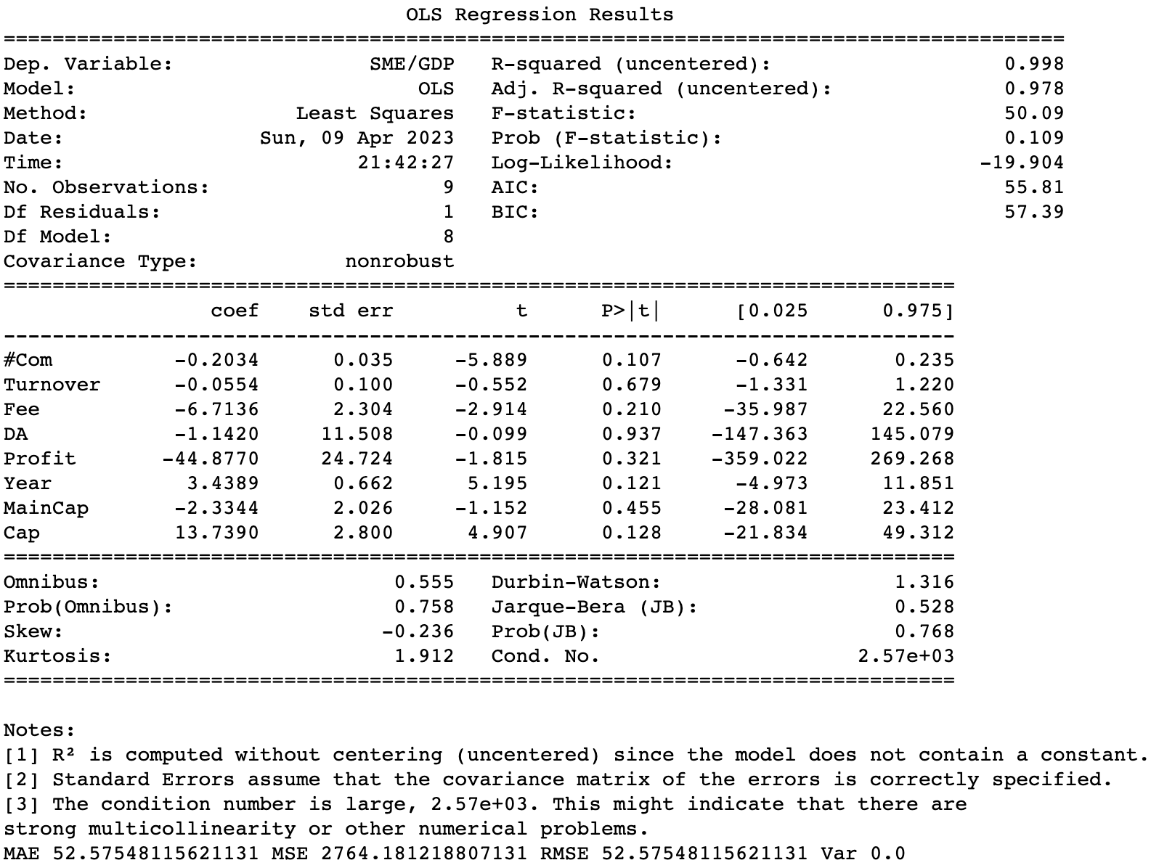

**Figure 6**: Results of the Multiple Regression 2

For multiple regression 2, we find that the coefficient of large-unit factors like capitalization and main board capitalization increased much. From the t-stats, we can find that the significant factors are: Number of Companies, Listing Fee, Year, and Market Capitalization of SME Board. We can see that the adjusted multiple regression tells us that the significant factors are mainly about the scale, maturity, and constraints to going public. A board with a large scale tends to increase SME owners’ confidence to raise money. And reducing the difficulties of SMEs to go public, like making the listing fee lower, will also help boards attract SMEs and improve their performance.

In order to compare better with later methods such as LASSO and find a more suitable method. We want to measure the results of the model with both Mean Absolute Error and Variance. Since it is difficult to divide a small sample set of only 10 samples into training and testing groups, we use k-fold cross-validation, using only one sample at a time as the test group, and repeated this process ten times. This allows us to measure the performance of the model using the average MAE and Variance of the 10 groups.

After 10 groups of training and testing, the average MAE of multiple regression is 4.55, and the average variance is 162.19.

In addition, we can find that the R-square is very high. On the one hand, this shows that our factors explain much of the problem, but on the other hand, this is also because we have too many factors and a relatively small size of samples. And that’s why methods of LASSO and PCA are conducted next.

**LASSO Regression**

LASSO is a supervised learning method that deals with overfitting, with it, parts of the bias will be given up to exchange for a little variance. And the result is that we can efficiently cut some insignificant factors by forcing their weight to be 0, only leaving the important ones. With LASSO’s help, we have the new results:

|  |  |
| --- | --- |
| Factor | Coefficient |
| #Com | -0.07 |
| Turnover | -0.01 |
| Fee | -2.92 |
| DA | 0 |
| Profit | 0 |
| Year | 0.80 |
| MainCap | -0.66 |
| Cap | 2.33 |

**Table 2**: Coefficients of LASSO Regression

We can see that the results basically match the multiple regression: some less significant factors are removed like whether there is a DA requirement and profit requirement. Most of the factors that are significant in multiple regression like capitalization and listing fee are still large coefficients in LASSO. But one exception is for the number of companies with high t-stat in the multiple regression. Although it is not removed in LASSO, its weight is relatively low. To compare the two methods, we do the k-fold cross-validation again. The LASSO’s average MAE is 9.39, larger than multiple regression, and its variance is 135.81, smaller than multiple regression. This makes sense because LASSO sacrifice bias for little variance.

**Random Forest**

Then we move to the Random Forest (RF) to make the prediction, which can deal with the non-linear relationship. Different from the random tree, due to the method of random selection and average calculation, the Random Forest reduces overfitting and is more suitable for this paper.

We use the average of the attribute feature_importances_ to find the importance of each factor. Because the relationship is non-linear and the problem is solved by random forest this time, we don’t have coefficients. The importance of each factor is as below:

|  |  |
| --- | --- |
| Factor | Importance in RF |
| #Com | 2.76 |
| Turnover | 0.46 |
| Fee | 3.47 |
| DA | 0.05 |
| Profit | 0.21 |
| Year | 0.74 |
| MainCap | 0.81 |
| Cap | 1.55 |

**Table 3**: Significance of Random Forest

The results match the LASSO and multiple regression to some extent. For example, for listing fee and capitalization which are both significant in the two former methods, they still have high weights in RF (3.47 and 1.55). And the factors that are not significant in the two former methods like Profit and DA are still not significant here. What’s more, for #Com which has a low weight in LASSO but high significance in multiple regression, its importance is also high in RF.

The Random Forest’s average MAE here is 8.93, larger than multiple regression but smaller than LASSO, and its variance is 13.78, the smallest of the three methods. The RF method dominates the LASSO, and has a moderate MAE. What’s more, because of the characteristics of RF that they are made up of many weak classifiers that are trained completely independently, the overfitting problem is also less likely for RF than for multiple regression. So, the RF method is chosen as the most appropriate model.

|  |  |  |
| --- | --- | --- |
| Model | MAE | Variance |
| Multiple Regression | 4.55 | 162.19 |
| LASSO | 9.40 | 135.81 |
| Random Forest | 8.93 | 13.78 |

**Table 4**: Two Metrics for Three Models

**PCA**

Principal component analysis (PCA) is useful to combine some highly correlated variables and find the most explanatory factors, conducting dimensionality reduction. Using this method, we can also find out the importance and correlation of factors.

We cannot use the method of comparing the error and the variance of PCA with other models because PCA is an unsupervised learning method used in dimension reduction. So we use it to confirm the results given by the former three models.

PCA aims to make the eight factors into some components, combining some highly correlated ones. After standardization and fitting, the number of components, N is respectively set from 1 to 8. To achieve the goal of dimension reduction, we find the smallest number of components that can explain more than 90% of the total variance.图表, 折线图
According to Figure 7, the number of components chosen is five (explaining 93.4% of the variance).

**Figure 7**: Components Eigenvalue in PCA (2-5 components)

Figure 8 is a visual matrix made to see how the new components relate to the original variables. Component 0 is mainly correlated to Capitalization; Component 1 is related to listing fee and the year of existence; Component 2 is strongly correlated to the capitalization of the main board; Component 3 is again about the year of existence; Component 4 is about DA requirement and the MainCap. Besides significant factors we talked about before like capitalization, listing fee, and year, the dummy variable DA plays a more important role in PCA’s component 4. And the significance of #Com is not represented in the PCA model.

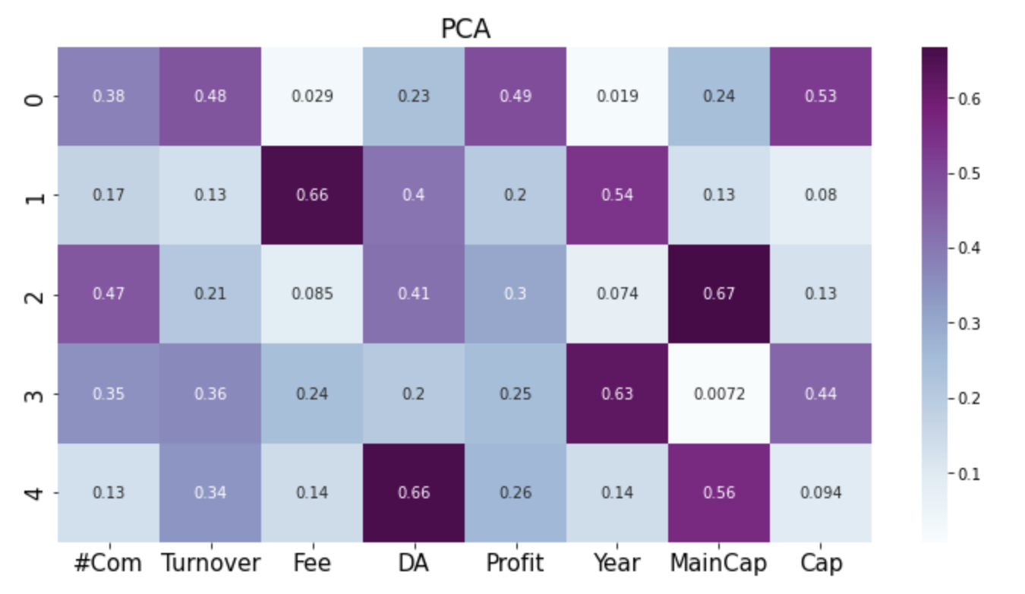

**Figure 8**: Visualization of PCA Result

**Results and Suggestions**

Comparing the four methods, most of the conclusion match with several exceptions. Models like LASSO and reduction focus more on reducing factors and making a smaller variance, while Random Forest deals with the non-linear relationship. As the metrics comparison made in the RF section, we choose RF as the most proper model and use PCA to consolidate it.

The final result is that listing fees, number of companies, and capitalization are the most important factors for the success of the SME board. And turnover ratio is not as significant as we thought, maybe it is because the variance of the samples’ turnover ratios is large or the liquidity itself is highly correlated with capitalization and the number of company (that’s also why PCA combine it into component 1 with capitalization mainly). Furthermore, the dummy variable of profit is not significant in the four models, and the reason may be most of the samples have “1” in this factor. But in multiple regression 2, the coefficient of profit is -44.9, which makes sense because the profit requirement increases the difficulty of going public.

|  |  |  |  |  |
| --- | --- | --- | --- | --- |
| Factor | Multiple Regression | LASSO | Random Forest (Importance Rank) | PCA (significant in n components) |
| #Com | t-stat > 1.96 | kept | 2 |  |
| Turnover |  | kept | 6 |  |
| Fee | t-stat > 1.96 | kept, coefficient > 2 | 1 | 1 |
| DA |  | removed | 8 | 1 |
| Profit |  | removed | 7 |  |
| Year | t-stat > 1.96 | kept | 5 | 2 |
| MainCap |  | kept | 4 | 2 |
| Cap | t-stat > 1.96 | kept, coefficient > 2 | 3 | 1 |

**Table 5** Significance of Factors Based on Four Models

Besides general suggestions of expanding the scale of the SME board and reducing the listing fee, a sensitivity analysis may give more quantitative suggestions. Because the listing fee can be set subjectively by the board (unlike the capitalization of all the listing companies that cannot be decided by the board), we first do the sensitivity analysis for Nigerian Listing Fee using Random Forest. The partial results are as below:

|  |  |  |
| --- | --- | --- |
|  | Listing Fee | Predicted SME/GDP (%) |
| Nigeria 1 | 0 | 44.78 |
| Nigeria 2 | 50 | 44.78 |
| Nigeria 3 | 100 | 42.40 |
| Nigeria 4 | 150 | 42.40 |
| Nigeria 12 | 400 | 42.40 |
| Nigeria 21 | 570 | 41.46 |
| Nigeria 26 | 1070 | 41.46 |

**Table 6** Sensitivity Analysis of Nigerian Growth Board Listing Fee

Since we use the “log” listing fee to modify the data so that the difference between dependent and independent variables will be smaller, the result of the sensitivity report will be based on range. For example, from the current $570, if the Growth board increases its listing fee to $1070, based on our model the predicted SME/GDP will not change. But if the listing fee is reduced to $400, the SME/GDP will become higher (from 41.46% to 42.4%), and if it is further reduced to $50, the performance will be better (44.78%). And we can see that in our RF model, even if the listing fee is canceled, the performance will still be the same as the $50 fee. Then we do a similar analysis for the requirement of a designated adviser.

|  |  |
| --- | --- |
|  | Predicted SME/GDP (%) |
| Thailand 1 | 38.95 |
| Thailand 0 | 38.73 |
| India 1 | 30.37 |
| India 0 | **30.47** |
| Malaysia 1 | 38.72 |
| Malaysia 0 | 38.67 |
| Mauritius 1 | 43.23 |
| Mauritius 0 | 43.05 |
| Jamaica 1 | 42.42 |
| Jamaica 0 | 42.24 |
| Nigeria 1 | 47.35 |
| Nigeria 0 | 47.21 |
| Ghana 1 | 54.16 |
| Ghana 0 | 54.03 |
| Poland 1 | 30.51 |
| Poland 0 | 30.50 |
| South Africa 1 | 38.06 |
| South Africa 0 | 37.89 |
| China 1 | 39.88 |
| China 0 | **39.92** |

Table 7 Sensitivity Analysis of Requirement of DA in 10 Countries

The results show that in all of the countries’ SME boards except India and China, the existence of the designed advisor will be helpful to increase SMEs’ contribution, proving the importance of the listing information and education for SME owners.

**Conclusion**

SMEs in developing countries such as Nigeria have major contributions to employment and GDP, but at the same time face a huge financial gap. SME stock exchange boards like the Nigerian Growth Board are an important way to solve this problem. This paper evaluates the success factors of SME boards by multiple regression, LASSO, and Random Forest, and it uses PCA to validate and consolidate the conclusion. The conclusion is that capitalization scale, number of companies, and listing fee are the most important factors for SME boards. In particular, the sensitivity analysis for Nigeria proves that maintaining the relative advantage of the low listing fee and further reducing the listing burden of SMEs is conducive to further stimulating the development of SMEs; The mandatory allocation of advisors is also conducive to the listing of SMEs. At the same time, although liquidity is less important in each model, this may be due to the large extreme differences in the sample data. Growth Board should still pay attention to increasing the confidence of more SME owners to obtain funding by improving liquidity. This research is not only beneficial for the existing SME boards but will also shed light on other countries when they consider the need to establish new SME boards in the future.

The small sample size is the limitation of this paper, mainly because there are only about 20 SME boards in the world. This paper has used K-fold cross-validation and simulation + sensitivity analysis to solve this problem. In the future, extending the virtual sample size with more complex simulations (e.g., simulating 8 factors together) should also be considered. In addition, time series analysis for different samples is also a potential approach if time series data for each board is available.

Works Cited

Egwuatu, Peter. “Why SMEs Are Not Attracted to List on the Nigerian Stock Exchange.” Vanguard, 2017, https://www.vanguardngr.com/2017/01/smes-not-attracted-list-nigerian-stock-exchange/.

Gakweli, Mwakaneno. “Lessons from the JSE: AltX, an Alternative Exchange for Medium-Sized Companies.” 2019, https://kenyanwallstreet.com/lessons-from-the-jse-altx-an-alternative-exchange-for-medium-sized-companies/.

Gololo, Ibrahim Aliyu. “An Evaluation of the Role of Commercial Banks in Financing Small and Medium Scale Enterprises (Smes): Evidence from Nigeria.” Indian Journal of Finance and Banking, vol. 1, no. 1, 2017, pp. 16–32., https://doi.org/10.46281/ijfb.v1i1.82.

Lai, Karry. “New Beijing Stock Exchange Provides IPO Springboard for SMEs.” *International Financial Law Review*, 2021.

Liu, Yan, and Tian Xie. “Model Uncertainty of Determinants of Cross-Country Economic Growth: A New Framework Based on Machine Learning.” China's Industrial Economy, vol. 12, 2019, https://doi.org/10.19581/j.cnki.ciejournal.2019.12.001.

Maher, Maria E., and Thomas Andersson. “Corporate Governance: Effects on Firm Performance and Economic Growth.” SSRN Electronic Journal, 2000, https://doi.org/10.2139/ssrn.218490.

Obieche, Precious Nkechi, and Peters O. Ihejirika. “Bank Credit and Smes Financing in Nigeria.” Journal of Economics and Sustainable Development, 2021, https://doi.org/10.7176/jesd/12-14-04.

Octavia, Evi, et al. “The Effect of Deffered Taxes, Tax Ratio and Board Financial Education on the Financial Statements of Indonesian Stock Exchange: Role of Regional Disparity Knowledge.” REVIEW OF INTERNATIONAL GEOGRAPHICAL EDUCATION, vol. 11, no. 3, 2021, https://doi.org/10.48047/rigeo.11.3.35.

Ovat, Okey. “Commercial Banks' Credit and the Growth of Small and Medium Scale Enterprises: the Nigerian Experience.” IOSR Journal of Economics and Finance, vol. 7, no. 6, 2016, pp. 23–30. IV, https://doi.org/10.9790/5933-0706042330.

Ozturk, Ilhan. “The Role of Education in Economic Development: A Theoretical Perspective.” SSRN Electronic Journal, XXXIII, no. 1, 2008, pp. 39–47., https://doi.org/10.2139/ssrn.1137541.

Peterhoff, D., et al. “Towards Better Capital Markets Solutions for SME Financing.” Oliver Wymann, 2014, https://www.oliverwyman.de/content/dam/oliver-wyman/global/en/files/insights/financial-services/2014/July/FINAL3_BetterCapitalMarketMechanismsSMEs.pdf.

Schellhase, John, and Jim Woodsome. “SMEs and Public Equity Financing: A New Dataset of SME Boards in Emerging-Market and Developing Economies.” Milken Institute, 2017.

The Nigerian Stock Exchange. Growth Board A Guide to Listing, Nigerian Stock Exchange., https://ngxgroup.com/ngx-download/growth-board-listing-guide/?ind=1606291891775&filename=1606291891wpdm_Growth%20Board%20Listing%20Guide.pdf&wpdmdl=27190&refresh=643270c6b8dc01681027270.

Thomas, David. “Nigeria Launches Development Bank to Support SMEs.” African Business, 6 Feb. 2017., https://african.business/2017/02/trade-investment/nigeria-launches-development-bank-support-smes.

2020, pp. 7–8, PwC’s MSME Survey 2020 Building to Last Nigeria Report., https://www.pwc.com/ng/en/assets/pdf/pwc-msme-survey-2020-final.pdf.